Experiment-13

Aim
To perform affine transformation on an image using Python and OpenCV.

Procedure
- Import the OpenCV and NumPy libraries.
- Read the input image using cv2.imread().
- Obtain the dimensions of the image.
- Define three points in the original image and their corresponding destination points.
- Calculate the affine transformation matrix using cv2.getAffineTransform().
- Apply the transformation using cv2.warpAffine().
- Display the original and transformed images.

Code
import cv2import numpy as np
img = cv2.imread("image.jpg")rows, cols = img.shape[:2]
pts1 = np.float32([[50, 50], [200, 50], [50, 200]])pts2 = np.float32([[10, 100], [200, 50], [100, 250]])
matrix = cv2.getAffineTransform(pts1, pts2)
result = cv2.warpAffine(img, matrix, (cols, rows))
cv2.imshow("Original Image", img)cv2.imshow("Affine Transformation", result)
cv2.waitKey(0)cv2.destroyAllWindows()

Sample Input
An image named image.jpg.

Sample Output
- Original image displayed in the first window.
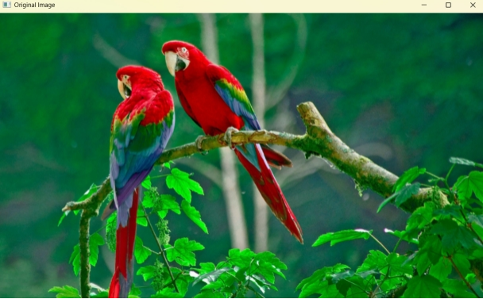
- Affine-transformed image displayed in the second window with changes in position, shape, or orientation.
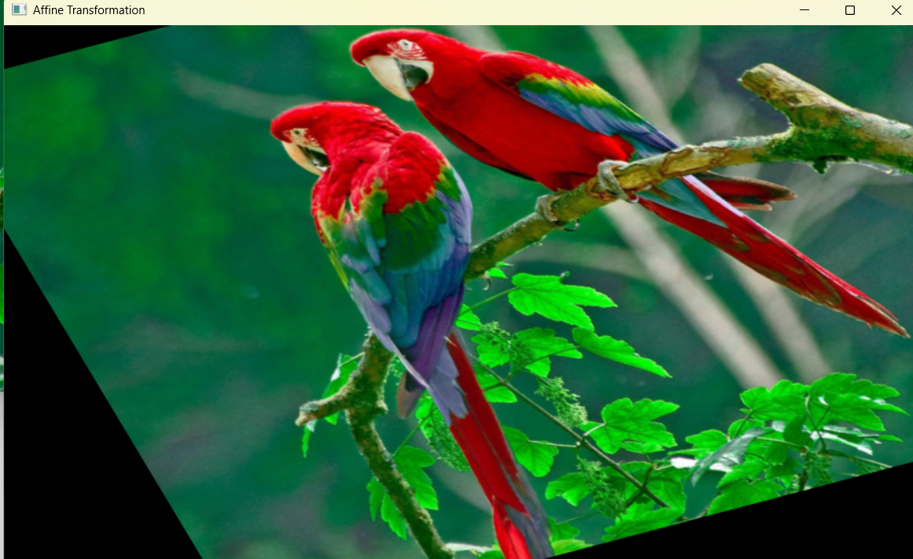

Result
Thus, affine transformation was successfully performed on the input image using Python and OpenCV.

